***The Harbor Ridge Homeowner***

**A Publication of the Harbor Ridge Homeowners Association Spring 2016**

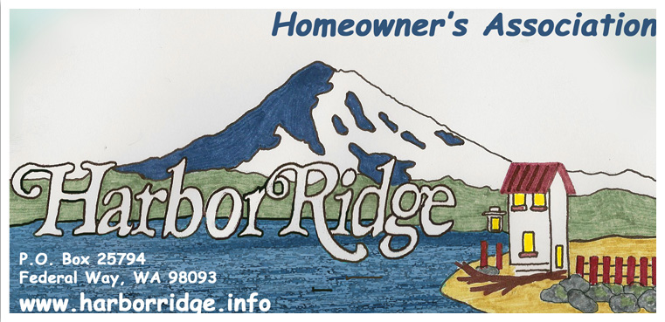

**WARM WEATHER REMINDERS**

Spring is here and summer is just around the corner. The warmth of the growing season is a great reminder that vegetation needs to be kept back to keep everyone safe. Make sure spring growth hasn’t caused your plants to obstruct the view of oncoming traffic, kids on bikes, and pedestrians out enjoying all this season has to offer.

More sunshine means more vitamin D, which gives us a boost of energy. Did you also know that sunlight increases the power of the immune system and has been found to help with insomnia? Our community’s parks, trails and beaches have so much to offer and we encourage everyone to get outside and make the most of the warm weather ahead. As we enjoy the sun, it’s important to remember that hot weather can dehydrate our bodies even faster. Drink plenty of water when you get outside to play or work in the yard.

Lawns need water too and this is best done during the cool hours of the day to conserve natural resources and save money on your water bill. If you find you have an abundance of garden vegetables or fruits this season, some local food banks accept these items in summer months. You can also reach out to a board member who may be able to refer you to a local charity that provides fresh food to the elderly and those in need.

This is also a good time for some summer safety reminders. Our neighborhood narrowly avoided a major loss last July when fireworks started a fire at a Harbor Ridge property. Please remember safety first and leave the fireworks displays to the professionals. Warm weather also means extended travel and vacations. Leaving property unattended can be worrisome. Get to know your neighbors and let each other know when you will be out of town. That way you can keep an eye on things and contact each other if something seems wrong.

**OPERATING PROCEDURES**

One of the goals of the Harbor Ridge Homeowners Association is to increase community connectivity and participation. After 23 years of operating under the original by-laws, an updated document was recently adopted by the Board and renamed the Operating Procedures. The updated Procedures explain how our neighborhood Conditions, Covenants and Restrictions (CC&R’s) are implemented. For example, they explain more clearly how new board members are nominated and elected. They also explain how every household has the opportunity for ongoing input and a chance to participate in the business of the Association. The revisions are now available for viewing on the Harbor Ridge Homeowners Association web site under “Operating Procedures.” Our meeting schedule is also available on the website and we welcome you to attend. Details at: [www.harborridge.info](http://www.harborridge.info)

**CC&R ENFORCEMENT POLICY**

To clarify any misunderstanding in the community with regard to responsibilities for enforcing CC&R’s, Article VII (General Provisions), Section I (Enforcement) states*: “Any owner, shall have the right to enforce, by any proceedings at law or in equity, all restrictions, conditions, covenants, reservations, and charges now or hereafter imposed by the provisions of this Declaration.* Clearly this can involve long and costly litigation. The developer, at the time the Harbor Ridge plat was established back in 1980, did not provide mechanisms of authority enabling direct levying of fines/penalties for Covenant violations.

By contrast, developments platted in subsequent years have mechanisms for rapid and rigid enforcement. Some people may view the latter positively, but others may see it as a negative. For example, many trees planted by homeowners in the Harbor Ridge are in violation of the 15-foot height restriction, but they may trouble no one. Some folks like the taller trees because they may provide barriers or provide shade during a hot summer day. However, those very trees or hedges may create an obstruction to the views of other residents.

The Covenants make it clear that it is each homeowner’s responsibility to initiate CC&R enforcement. However, the board will provide assistance to achieve resolution, up to and including monetary participation if the complaint is reasonable, the violations are clear, and the aggrieved neighbor experiences difficulty achieving the desired results. Prior to asking for board assistance, we ask each owner to take some steps to resolve violations by communicating and working directly with the neighbor(s) involved. If you have an issue to bring to the Board’s attention, please come to a meeting or visit our website at www.harborridge.info to contact us using email.

**CAR THEFT AND VEHICLE BREAK-INS**

We recently had a car stolen from our Harbor Ridge neighborhood and two get broken into. The car was stolen from Osprey Drive and the break-ins occurred on Silver Bow. We encourage everyone to be vigilant and look out for your neighbors. To help you, here are five actions we can all do immediately to keep our homes and community safe:

* **Don’t leave any items visible in your car.**
* **Make your car and home less attractive to criminals**.   
  Trim shrubbery and trees so your doors, windows, driveways and sidewalks are visible; keep your porch light on at night; install motion sensors/security lighting on all sides of your home so that it is located high, out of reach and is vandal resistant.
* **Conceal electronic devices and accessories.**Stow all electronics and accessories out of sight, including car chargers, iPod adapters, cell phone/GPS windshield suction-cup mounts, etc. Also, record the serial numbers of GPS devices and other equipment and keep the numbers in a safe place in your home.
* **Use your car alarm and consider purchasing a theft deterrent device.** “The Club” is available for $35 on Amazon.com.
* **If you hear an alarm or a window breaking, look outside and call 911.**

Most importantly, one of the best ways to deter crime is to organize our neighborhood. You are invited to a community meeting with the Tacoma Police Department and Safe Streets to learn more about resources are available for us all to work together to keep crime out of our community. The meeting is scheduled for June 29,6:00PM at the NE Tacoma Police Substation: 4731 Norpoint Way **NE, Tacoma. I**f you are interested in attending, please email board member Michael Grayum at [michaelgrayum@gmail.com](mailto:michaelgrayum@gmail.com). If you have questions about the recent incidents, please contact our Community Liaison Police Officer, Brandon Showalter at [Brandon.showalter@cityoftacoma.org](mailto:Brandon.showalter@cityoftacoma.org). **Remember, if you see something, say something.**

**SPRING CLEAN-UP**

Many residents came together in April to do a little spring cleaning at the main entrances of our community and it looks fantastic. Weeding flower beds, trimming trees and ferns, and adding new soil, beauty bark and river rock were some the recent improvements. Please visit the Harbor Ridge website projects menu under 2016 spring landscape section to appreciate the landscape work and see before and after pictures. Thank you to everyone involved!

We encourage everyone to look for ways to make a positive difference in our community. If you would like to initiate and coordinate a community project, please let us know and we will be glad to spread the word and help bring people together.

***DUES ARE DUE***

Annual dues are still only $35 and can be sent via mail to the following address:

**Harbor Ridge Homeowners Association**

**P.O. Box 25794**

**Federal Way, WA 98093-2794**